SEMESTER TWO
Papers written by
Australian Maths Software

YEAR 12

MATHEMATICS METHODS

REVISION 3
Units 3-4

2016

Section One
(Calculator–free)

Name: _________________________________

Teacher: _______________________________

TIME ALLOWED FOR THIS SECTION

Reading time before commencing work: 5 minutes
Working time for section: 50 minutes

MATERIAL REQUIRED / RECOMMENDED FOR THIS SECTION

To be provided by the candidate
Standard items: pens, pencils, pencil sharpener, highlighter, eraser, ruler.

IMPORTANT NOTE TO CANDIDATES

No other items may be taken into the examination room. It is your responsibility to ensure that you do not have any unauthorised notes or other items of a non–personal nature in the examination room. If you have any unauthorised material with you, hand it to the supervisor before reading any further.

To be provided by the supervisor

Question/answer booklet for Section One.
A formula sheet which may also be used for Section Two.
Structure of this examination

 | Number of questions available | Number of questions to be answered | Working time (minutes) | Marks available | Percentage of exam
Section One  Calculator—free | 5 | 5 | 50 | 50 | 35
Section Two  Calculator—assumed | 13 | 13 | 100 | 100 | 65
Total marks |  |  |  | 150 | 100

Instructions to candidates

1. The rules for the conduct of this examination are detailed in the Information Handbook.
Sitting this examination implies that you agree to abide by these rules.

2. Write your answers in the Question/Answer booklet.

3. You must be careful to confine your responses to the specific questions asked and to
follow any instructions that are specific to a particular question.

4. Spare pages are provided at the end of this booklet. If you need to use them, indicate
in the original answer space where the answer is continued i.e. give the page number.

5. Show all your working clearly. Your working should be in sufficient detail to allow your
answers to be checked readily and for marks to be awarded for reasoning. Incorrect
answers given without supporting reasoning cannot be allocated any marks. For any
question or part question worth more than two marks, valid working or justification is
required to receive full marks. If you repeat an answer to any question, ensure that you
cancel the answer you do not wish to have marked.

6. It is recommended that you do not use pencil, except in diagrams.

7. The Formula Sheet is not to be handed in with your Question/Answer booklet.

1. (9 marks)

(a) The profit of a small company is graphed below. The profit is measure in
thousands of dollars and the time in months

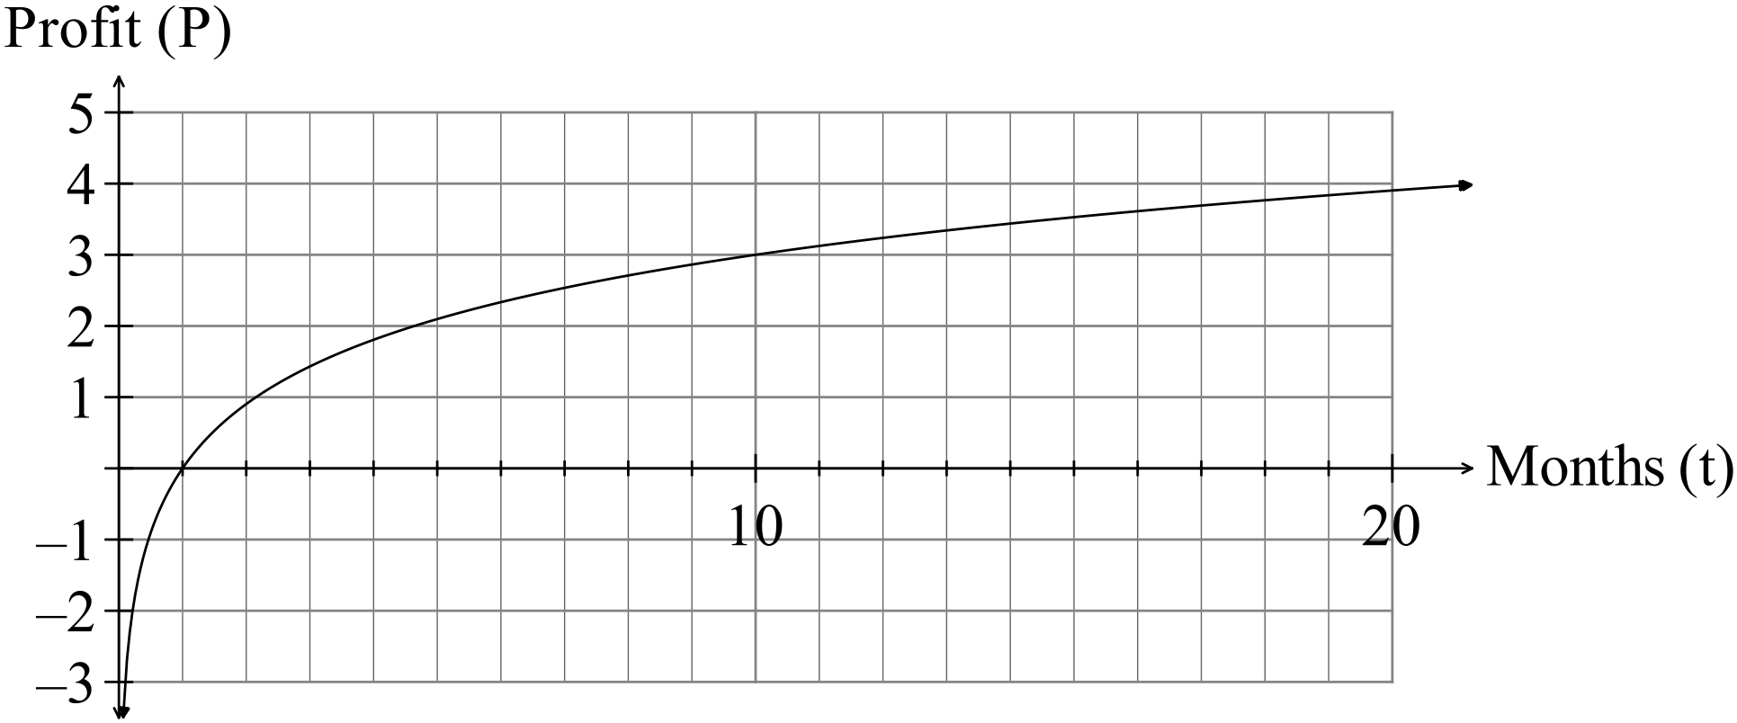

(i) When did the company “break even” i.e. start to make a profit? (1)

(ii) Determine the profit equation. (2)

(b) Determine given 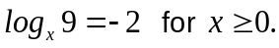 (3)

(c) Simplify
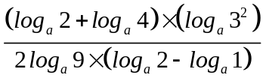 (3)

2. (14 marks)

(a) Find the derivative of
(i) 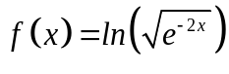 (2)

(ii) 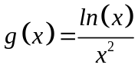 (3)

(iii) 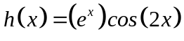 (2)

(b) The volume of a sphere is increasing at a rate of 3 cm³ s⁻¹. Find the rate of
increase of the radius when 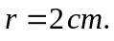 (3)
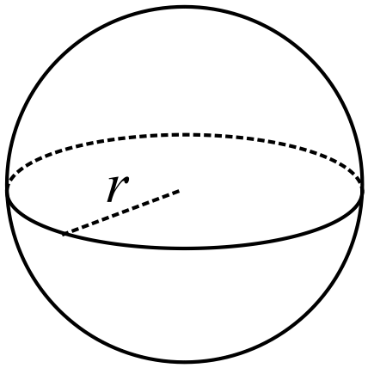

(c) Consider the functions
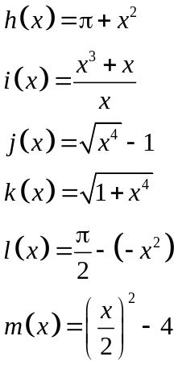
Many of the functions have the same derivative.

(i) Which of the functions have a different derivative to most of the others? (2)

(ii) Find the derivative of the functions where the derivative is not equal to 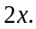
(2)

3. (7 marks)
(a) The graph of 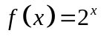 is shown on the set of axes below,
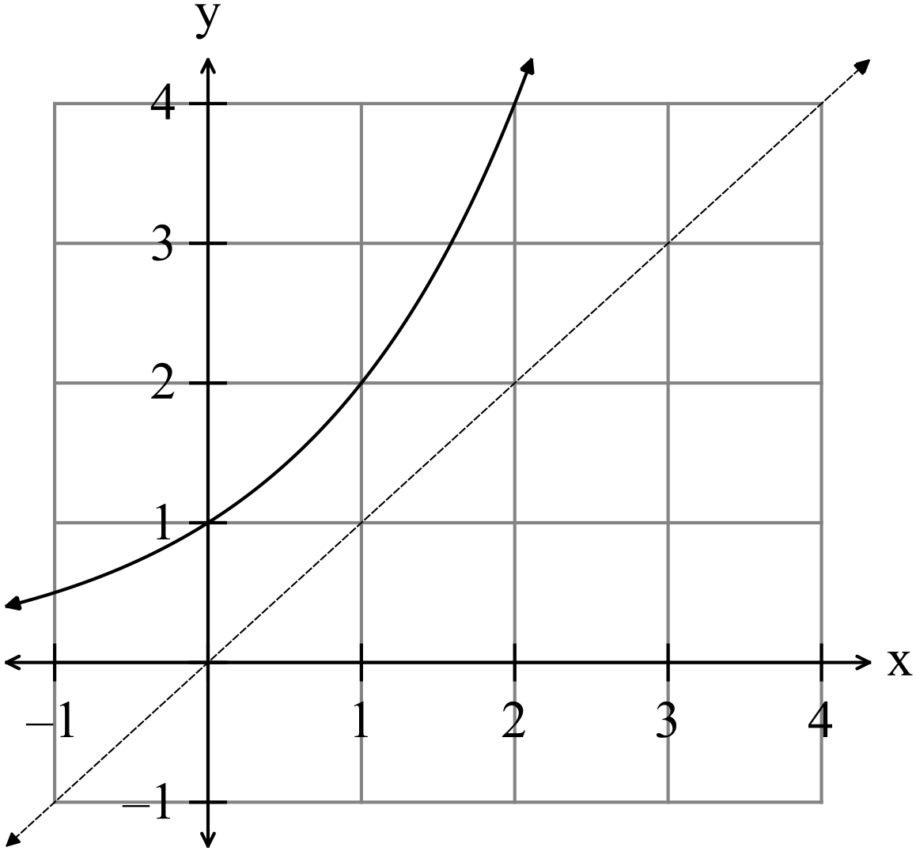

Sketch on the same set of axes

(i) 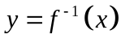, the inverse of the function. (2)

(ii) 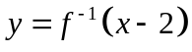 (3)

(iii) 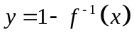. (2)

4. (9 marks)
Evaluate the following
(a) (i) 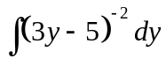 (2)

(ii) 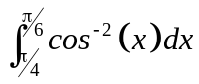 (2)

(iii) 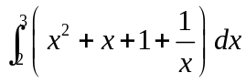 (3)

(b) If 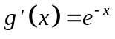find the expression for 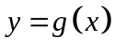given 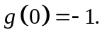 (2)
5. (11 marks)
(a) 50 samples of size 20 of a highly skewed distribution population, as shown in the
diagram, were taken and the mean of each calculated,

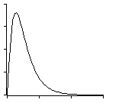
Sketch the shape of the distribution of the set of means of the samples. (2)

(b) Determine whether or not the function 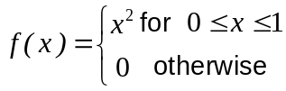 represents a
continuous probability density function. Give your reasons. (3)

(c) (i) Explain why the mean of the means of many samples of the same size is a
good approximation to the population mean. (2)

(ii) Explain why the sampling distribution (of the sample means) has a very
small standard deviation. (2)

(iii) Give three different types of bias that can be encountered when conducting
a survey. (2)

END OF SECTION ONE

